Synopsis

Olympic Medal Predictor

Problem Id: 26

Student Name-Avika A. Kush, Lopa
University Roll number- 2028680, 2028757
Section-k

- Problem Description:
- The Olympic Games involve complex competition where countries aim to maximize their medal performance based on various factors.
- Predicting Olympic performance is challenging due to multiple influencing variables such as athlete participation, number of events, and historical medal records.
- The main problem is to design an end-to-end machine learning system to analyze past Olympic data and predict future performance outcomes.
- The dataset consists of numerical features like country-wise participation, event statistics, and medal counts across different years.
- Real-world datasets often contain missing values, inconsistencies, and noise, which require proper data preprocessing techniques.
- Data cleaning, normalization, and transformation are applied to ensure data reliability and consistency.
- Exploratory Data Analysis (EDA) is performed to identify trends, patterns, and relationships in medal distribution and participation over time.
- Visualization techniques such as bar charts, line graphs, and heatmaps help in better understanding the data.
- Machine learning models are used to predict medal counts or classify performance into categories like high, medium, and low.
- A key challenge is selecting relevant features and building an accurate and efficient predictive model.
- The system is evaluated using appropriate performance metrics to ensure accuracy and reliability.
- The project provides insights into sports analytics and demonstrates the practical application of machine learning techniques.

- Steps of Implementation:
- Problem Definition:
The problem is defined to analyze historical Olympic data and predict the performance of countries using machine learning techniques.
- Data Collection:
The dataset is collected from reliable sources containing information such as country name, year, number of athletes, events participated, and medal counts.
- Data Preprocessing:
The collected data is cleaned by handling missing values and removing inconsistencies. Categorical variables are converted into numerical format, and normalization is applied to improve data quality.
- Feature Selection and Engineering:
Relevant features that influence Olympic performance are selected. Additional features such as total medals are created to enhance the dataset.

- Exploratory Data Analysis (EDA):
Data is analyzed using statistical methods to identify patterns, trends, and relationships between variables like participation and medal counts.
- Data Visualization:
Graphical representations such as bar charts, line plots, are used to better understand trends and correlations in the dataset.
- Model Selection and Training:
Suitable machine learning models such as Multiple Linear Regression are selected and trained using the processed data.
- Prediction:
The trained model is used to predict Olympic performance in terms of medal counts.
- Classification of Results:
The predicted values are categorized into performance levels such as High, Medium, and Low for better interpretation.
- Model Evaluation:
The performance of the model is evaluated using metrics such as Mean Absolute Error (MAE) and R² score.
- Result Analysis:
The results are analyzed to draw meaningful insights about country-wise Olympic performance and trends.
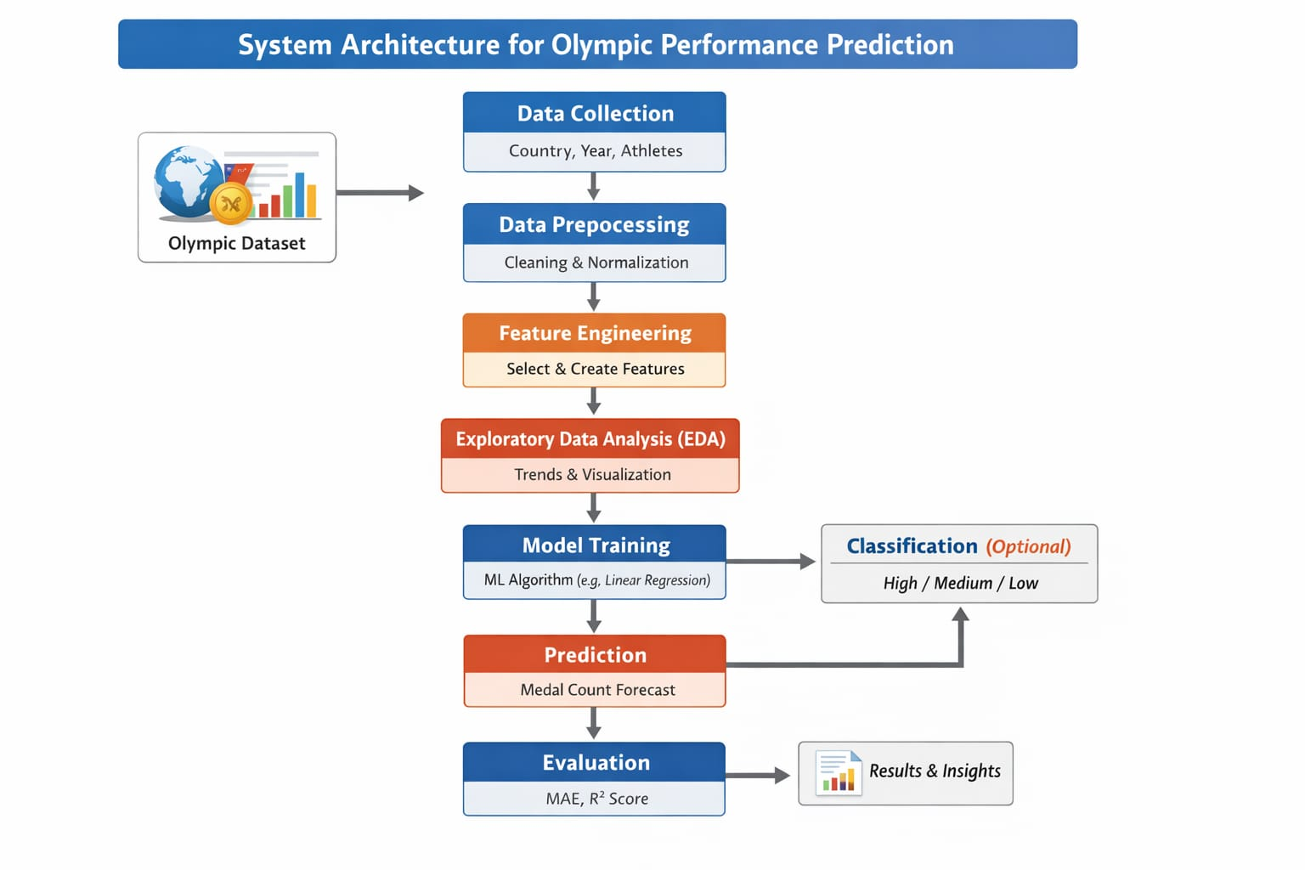
Fig. 1 architecture
- Expected Modules/ Libraries to be used:
- Pandas
- Used for data manipulation and analysis.
- Helps in handling datasets, missing values, and data preprocessing.
- NumPy
- Used for numerical computations and array operations.
- Provides efficient mathematical functions for data processing.
- Matplotlib
- Used for data visualization.
- Helps in plotting graphs such as line charts and bar graphs.
- Seaborn
- Used for advanced data visualization.
- Useful for heatmaps and statistical plots.
- Scikit-learn (sklearn)
- Used for implementing machine learning algorithms.
- Includes models like Multiple Linear Regression and tools for training, testing, and evaluation.

- Expected Evaluation metrics and Plots to be used:
- Mean Absolute Error (MAE):
- Measures the average absolute difference between actual and predicted values.
- Lower MAE indicates better model accuracy.
- Mean Squared Error (MSE):
- Measures the average of squared differences between actual and predicted values.
- Penalizes larger errors more than MAE.
- Root Mean Squared Error (RMSE):
- Square root of MSE, providing error in the same units as the target variable.
- Helps in better interpretation of prediction error.
- R² Score (Coefficient of Determination):
- Indicates how well the model explains the variance in the data.
- Value closer to 1 indicates a better fit.
- Accuracy (for classification):
- Used when predicted values are categorized into High, Medium, and Low.
- Measures the percentage of correct classifications.
- Bar Chart:
- To compare medal counts across different countries.
- Line Plot:
- To show trends in performance over different Olympic years.
- Scatter Plot:
- To analyze relationship between variables (e.g., athletes vs medals).
- Histogram:
- To observe distribution of medal counts.

- Required topics from the subject:
- Introduction to Machine Learning: Basic concepts of supervised learning and predictive modeling.
- Data Preprocessing: Handling missing values, data cleaning, normalization, and transformation.
- Exploratory Data Analysis (EDA): Statistical analysis and identification of patterns and trends in data.
- Data Visualization: Use of graphs such as bar charts, line plots, and heatmaps for better understanding.
- Feature Selection and Engineering: Identifying important variables and creating new features to improve model performance.
- Regression Techniques: Multiple Linear Regression for predicting continuous values like medal counts.
- Classification Techniques: Categorizing predicted results into classes such as High, Medium, and Low.
- Model Training and Testing: Splitting data into training and testing sets and building predictive models.
- Model Evaluation Metrics: MAE, MSE, RMSE, R² score, and accuracy for performance measurement.
- Python Libraries for Machine Learning: Use of Pandas, NumPy, Matplotlib, Seaborn, and Scikit-learn.

- Platform Required:
Jupyter notebook- Used as the development environment for writing and executing the code.
- Books and Link Sources:
- Python for Data Analysis-Wes Mckinney
- Pattern Recognition and Machine Learning- Christopher M. Bishop
- Matplotlib and Seaborn
- NumPy documentation
- Pandas documentation

